**CSE1341 – Lab #1**

## PRE-LAB [10 points]

**Must be done prior to your lab session.**

Read the “Java SE – JDK Installation Instructions " (found in Appendix A in the textbook, or provided by the instructor.) Install the JDK (Java Development Kit) on your own computer.

*All:* To use *java* and *javac* from the command line Mac: Spotlight: Terminal

Windows*: Start->Run... and enter **cmd**

All operating systems: Type the program below into a file name “FirstProgram.java” using Notepad (Windows) or TextEdit (Mac) and compile it using javac in the Windows CMD window / or Mac Terminal window. Execute it using the “java” command in the Windows CMD window / or Mac Terminal window. Mac users – see the note at the end of this document regarding settings in the TextEdit app.

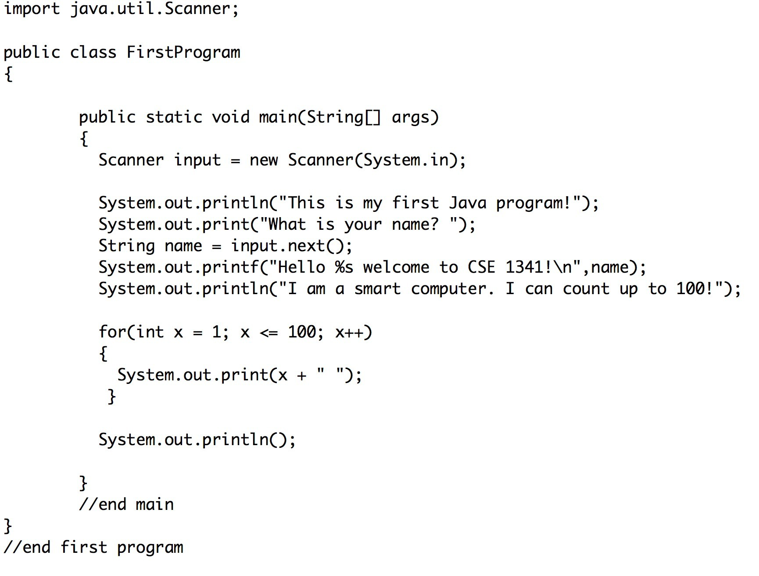

## If this compiles and executes correctly your installation of Java was successful. If you experience problems, bring your laptop to the lab and ask for help.

**LAB - Syntax Errors and Productivity Software [90 points]**

1. [10 points] Start with the program you typed and compiled. Remove the first curly brace ({) and try to compile your program. Paste the program and the error message into a word/open office document and explain what this message means.

Question 1  
Last login: Wed Aug 30 08:25:49 on ttys000

Michaels-MacBook-Pro-3:~ michaellink$ cd Desktop/

Michaels-MacBook-Pro-3:Desktop michaellink$ javac FirstProgramB.java

FirstProgramB.java:3: error: '{' expected

public class FirstProgramB

^

1 error

Michaels-MacBook-Pro-3:Desktop michaellink$

It means that Java is unable to compile the program into a byte coded class because it is missing a conventional opening brace.

1. Create a spreadsheet with solutions to the following three algorithm problems:

**2A** [30 points] – You have been hired to take inventory at *Main Street Hardware*. The owner wants a list of all products in the store with upc code, quantity on-hand, wholesale cost and retail price. For each item, calculate the potential gross profit as a dollar amount and as a percent. Also include the grand dollar total potential profit for the items on the list.

Include 10 unique products...you can make up your own data, but please conform to the format of the sample shown below, including cell formatting. The white cells contain data you type, and the shaded cells contain formulas that calculate the values:

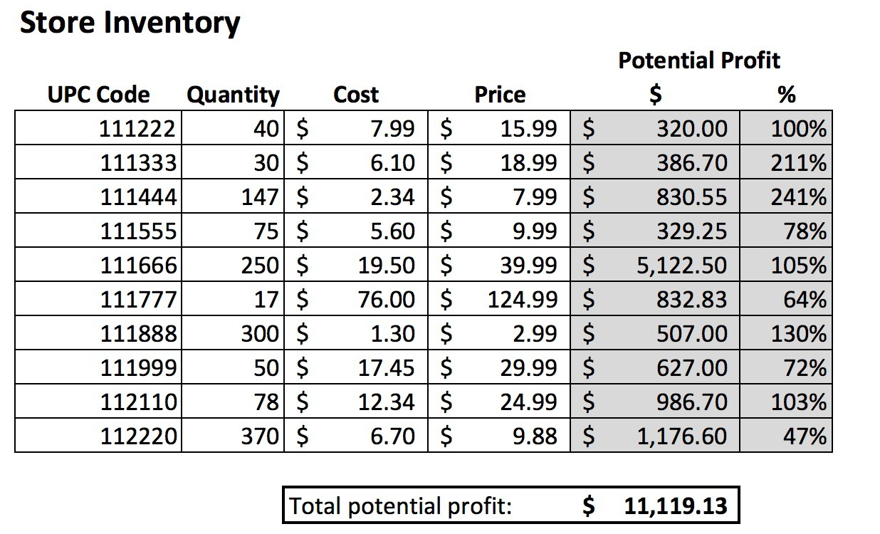

**2B** [10 points] – After reviewing the inventory, the hardware store owner realizes that the profit margins are inconsistent. Please create a calculator that allows you to enter a

target profit margin and cost, and calculates the retail price. In the example below, the shaded cell contains a formula that calculates its value. The other cells contain data entered by you.

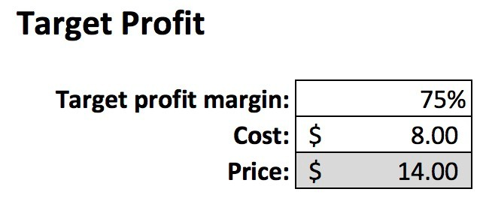

**2C** [20 points] – The Fibonacci sequence is a pattern of integers starting with zero and one, where each subsequent value is equal to the sum of the prior two values:

*Fn = Fn-1 + Fn-2, where F0 = 0 and F1 = 1.*

Create a spreadsheet which contains the first two numbers of the Fibonacci sequence, and calculates each the next 20 values:

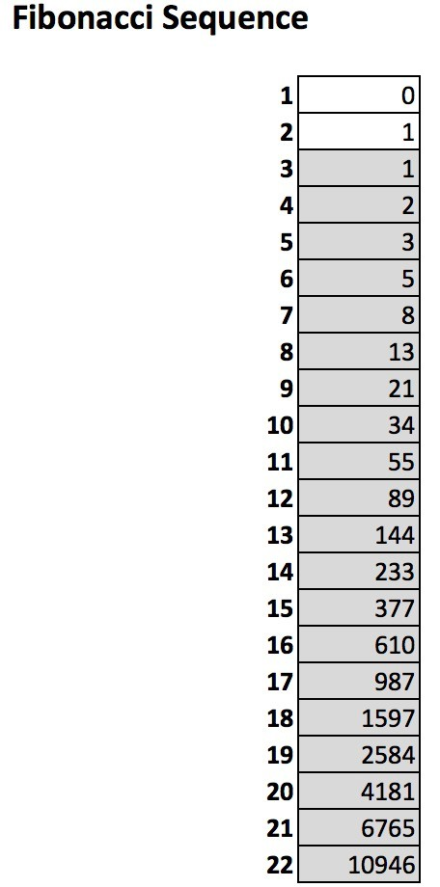

**2D** [20 points] – Create a spreadsheet that calculates the ***area*** of the following geometric shapes based on the known values you enter:

## Shape Known Values Entered

Square length of one side

Rectangle Length of two corresponding sides Triangle length of the base, length of the height Circle length of the radius

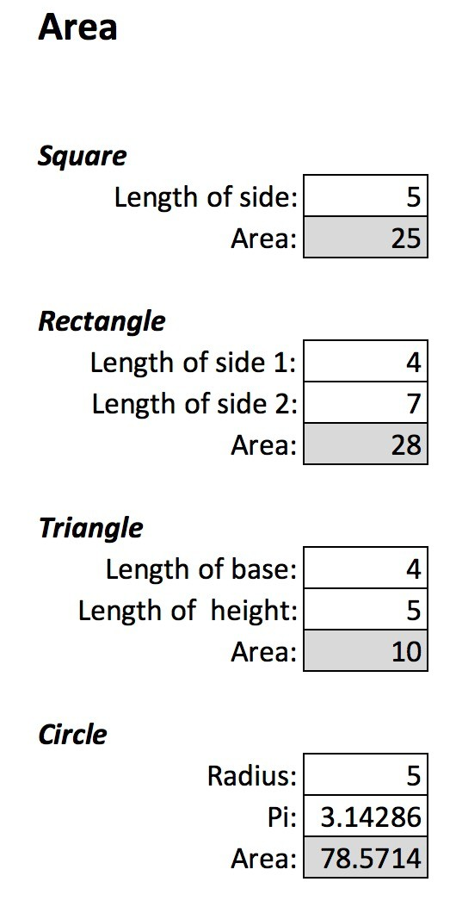

Submit the document and spreadsheet via Canvas (as a single zip-file).

# This assignment is due by 6:00AM Saturday, September 9.

**Additional Note for Mac Users:**

The TextEdit app must be set up for plain text with no smart quotes to properly create and save a document that the compiler can read. Before starting, open preferences in TextEdit and make sure the settings match the following:

